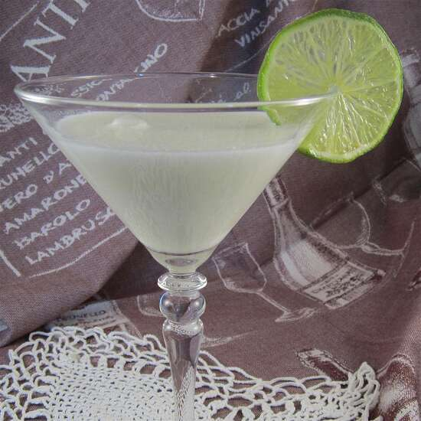 Recipe for Key Lime Martini

Ingredients for 1 serving:
- ice, as needed
- ½ fluid ounce vanilla-flavored vodka
- ½ fluid ounce key lime juice
- ½ fluid ounce simple syrup
- ½ fluid ounce half-and-half
Directions: Place ice cubes into a cocktail shaker about 3/4 full. Pour vodka, lime juice, simple syrup, and half-and-half over the ice cubes, shake, and strain into a martini glass. Goes well with book discussions about The Surrogate by Lynn Katz
https://www.lynnkatzauthor.com

